Student Name: Muhammad Adnan Rasheed
Roll Number: SU92-BSCSM-F25-324
Program: BSCS
Semester: 3rd Semester
Subject: COAL-Lab
Session: Fall 2026
Home Tasks:
- Largest of Three Numbers
- Type of Triangle
- Classify a Character

Home Tasks :-

Home Task 1: Largest of Three Numbers
.MODEL SMALL
.STACK 100H

.DATA
PROMPT1 DB 'Enter first number: $'
PROMPT2 DB 0DH,0AH,'Enter second number: $'
PROMPT3 DB 0DH,0AH,'Enter third number: $'
MSG DB 0DH,0AH,'Largest number is: $'

NUM1 DB ?
NUM2 DB ?
NUM3 DB ?

.CODE
MAIN PROC
MOV AX, @DATA
MOV DS, AX

LEA DX, PROMPT1
MOV AH, 09H
INT 21H

MOV AH, 01H
INT 21H
SUB AL, '0'
MOV NUM1, AL

LEA DX, PROMPT2
MOV AH, 09H
INT 21H

MOV AH, 01H
INT 21H
SUB AL, '0'
MOV NUM2, AL

LEA DX, PROMPT3
MOV AH, 09H
INT 21H

MOV AH, 01H
INT 21H
SUB AL, '0'
MOV NUM3, AL

MOV BL, NUM1
CMP BL, NUM2
JAE CHECK_THIRD
MOV BL, NUM2

CHECK_THIRD:
CMP BL, NUM3
JAE SHOW_LARGEST
MOV BL, NUM3

SHOW_LARGEST:
LEA DX, MSG
MOV AH, 09H
INT 21H

MOV DL, BL
ADD DL, '0'
MOV AH, 02H
INT 21H

MOV AH, 4CH
INT 21H
MAIN ENDP
END MAIN

Output :-
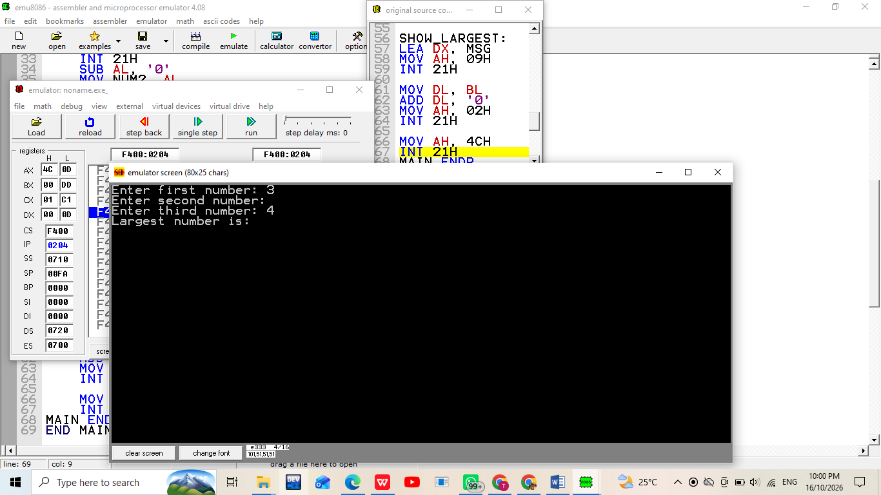

Home Task 2: Type of Triangle
.MODEL SMALL
.STACK 100H

.DATA
SIDE1 DB 5
SIDE2 DB 5
SIDE3 DB 3

NOT_TRI DB 'Not a triangle$'
EQUILAT DB 'Equilateral$'
ISOSCEL DB 'Isosceles$'
SCALENE DB 'Scalene$'

.CODE
MAIN PROC
MOV AX, @DATA
MOV DS, AX

MOV AL, SIDE1
ADD AL, SIDE2
CMP AL, SIDE3
JLE NOT_TRIANGLE

MOV AL, SIDE1
ADD AL, SIDE3
CMP AL, SIDE2
JLE NOT_TRIANGLE

MOV AL, SIDE2
ADD AL, SIDE3
CMP AL, SIDE1
JLE NOT_TRIANGLE

MOV AL, SIDE1
CMP AL, SIDE2
JNE CHECK_OTHER_EQUAL

CMP AL, SIDE3
JE EQUILATERAL_TRI
JMP ISOSCELES_TRI

CHECK_OTHER_EQUAL:
MOV AL, SIDE1
CMP AL, SIDE3
JE ISOSCELES_TRI

MOV AL, SIDE2
CMP AL, SIDE3
JE ISOSCELES_TRI

JMP SCALENE_TRI

NOT_TRIANGLE:
LEA DX, NOT_TRI
JMP DISPLAY_MESSAGE

EQUILATERAL_TRI:
LEA DX, EQUILAT
JMP DISPLAY_MESSAGE

ISOSCELES_TRI:
LEA DX, ISOSCEL
JMP DISPLAY_MESSAGE

SCALENE_TRI:
LEA DX, SCALENE

DISPLAY_MESSAGE:
MOV AH, 09H
INT 21H

MOV AH, 4CH
INT 21H
MAIN ENDP
END MAIN

Output : -
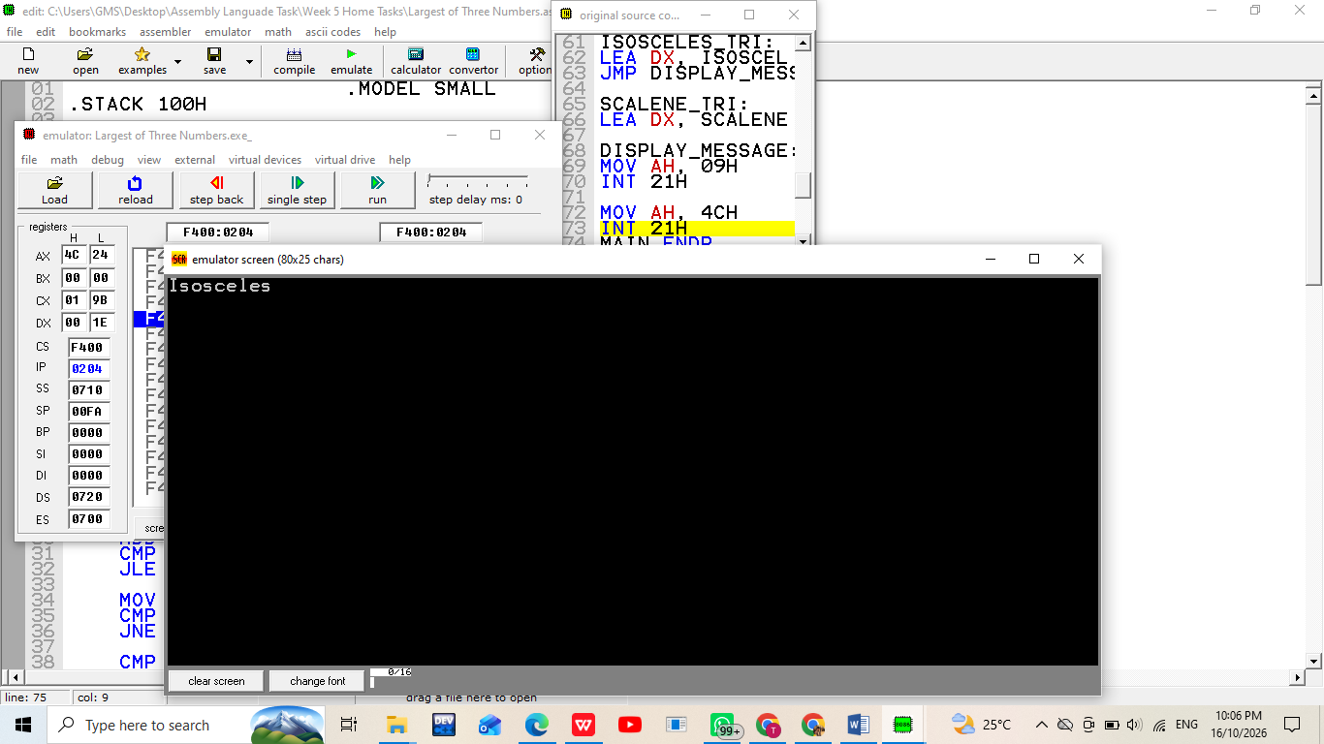

Home Task 3: Classify a Character
.MODEL SMALL
.STACK 100H

.DATA
PROMPT DB 'Enter a character: $'
NEWLINE DB 0DH,0AH,'$'

DIGIT_MSG DB 'Digit$'
UPPER_MSG DB 'Uppercase letter$'
LOWER_MSG DB 'Lowercase letter$'
OTHER_MSG DB 'Other symbol$'

.CODE
MAIN PROC
MOV AX, @DATA
MOV DS, AX

LEA DX, PROMPT
MOV AH, 09H
INT 21H

MOV AH, 01H
INT 21H
MOV BL, AL

LEA DX, NEWLINE
MOV AH, 09H
INT 21H

CMP BL, '0'
JB CHECK_UPPER
CMP BL, '9'
JBE IS_DIGIT

CHECK_UPPER:
CMP BL, 'A'
JB IS_OTHER
CMP BL, 'Z'
JBE IS_UPPER

CMP BL, 'a'
JB IS_OTHER
CMP BL, 'z'
JBE IS_LOWER

JMP IS_OTHER

IS_DIGIT:
LEA DX, DIGIT_MSG
JMP DISPLAY_RESULT

IS_UPPER:
LEA DX, UPPER_MSG
JMP DISPLAY_RESULT

IS_LOWER:
LEA DX, LOWER_MSG
JMP DISPLAY_RESULT

IS_OTHER:
LEA DX, OTHER_MSG

DISPLAY_RESULT:
MOV AH, 09H
INT 21H

MOV AH, 4CH
INT 21H
MAIN ENDP
END MAIN

Output :-
